Kl humne ye baat pade the ke jab bhaut bade samrajya ka patan hota hai to bahut chote chote rajyon ke utpatte hote hai
Bharat ke Madhya aur uttar Paschim wale chetro me vedeshe arthat Greek arthat yavano ke utpattee hote hai wahe bharat ke puriv aru dakshine chetro me swadeshi rajyon ke utpatee hote hai jo mukhya ruoop se brahman dharma ya vedic dharm ko mante the
To humen dekha ke india ke central aur north west regin me Greek rulers ate hai wahe india ke east aur south province me indeginous aur brahmin rulers dekhne ko mitle hai

Sathvahanas
Sathvahanas ke bare me intresting batt ye hai ke ye bharat per lagbhag 400 varsho tk shashan krte rahe ancient history me kise bhe dynasty ne itna lamba rule nahi kya hai bahut bada inka tim periid hai questin bhe puchete hai ke praching bharat me sabse lambe samya tk shashan karne wala rajvasnhs kaurn tha
To answer satvhand kae books me 300 aur kaie me 400 mention hai
Sathvahan ko Andhra satvahan ke naam se bhe jana jata hai aisa isley inke bare me do alag alag theory chalte hai ek theory hai ki inka origin andhrapradesh ke amravate wale regin me hua hai
Dusre inke origin ke theory hai ke maharastra me jo aurnagabad wla chetar hai wahah pratesthan naam ke Rajdhani to wahah se inke utpate hu hai origin hua hai yahe karan hai inhe andra sathvan ke naam se jana gayay hai
Mastsay puran me hume Andhra satvahan ke bare me bahut lambi chaude jankari milte hai

Sathvahan , Andhra bratya andhrajateya ye sabhe inke naam hai
Ye itheass me ku intan prasheesdh hua inme apko ek alag pratha dekhne ko milege

Isme kuch naam gautmi putra sathkane ke baad ke rajao me chke karo
Andhra sathavano ke rajao ne ek naee pratha shuru ke wo apne naam ke age apne mata ka naam lagate hai to iska matlab ye nahi hai ke smaaj matrastapmk tha samaja pitrastatmak he tha ye apen mata ke prate ek samman tha isse ye pata chalta hia ke women kae respect bahut Jayda rahe hoge but samaj patriarchal he tha kuki kabhe bhe kise mahela sahashek aka naam inke wansh me nahi tha only males rulen no women rune in theis dynasty
To agar matrastatbmak hot tha women bhe rulers hote hai aha wubt women ke respect the
To iss wajah se satvahan praseedh hai

Post Mauryan time per do famous hue hai ek sathvahan and dusra Kushan vansh

Satvhana ka first ruler tha simuk satkarna first great the
Haal ka shashan prashaans se Jayda sahetya literature k lyie charch me tha administration se kjyada literature me tha bahtu sare great liteatur work ist time per hue the

Yagyashree satkarni antim last great ruler tha jaise Mauryan me Ashoka last great ruler tha

Last ruler of sathvaans is pulumavi fourth
More than 30 rulers rulednd in this dynasty because they ruler over the period of 300 year
Hume sir famous char pach ke bare me he padna hai

Ye inek extreme extinision ke darshata hai ke ek samay pe inhone itne bade Chetra per shansan kyia tha
Gujrat me bhadoch naam ka ek port tha jo inka ek bahut mahdtvapuran prot tha see on map

Pratesthan inke capital the aur amravate bhe inke captioal rahe hai see on map

Pratesthan jjo ke mahrastra me Aurangabad ke paas wala ilaka hai
Haal me Aurangabad ka naam badalkar kya rakh dyia gaya hai

Sathvaahano ke pareele bhaut sare rjaja ya dynasty beech me shaashn kar rahe the
Western shatraps, Kushan empire shakio ke jo shaka Ujjain wale Chetra me the usko pashcami chatrap ya western chatrpa bhe bolte hai
Ancient Indian history me it is consider the longest ruling period by any dynasty

Simuk ko sindhuk aya siprak bhe bolte hai
Kanv vansh ke rajaj susharma ke htaya karke inhone sathvahan dynasty ke isthpana ke the

Kanv se pahle bhe yae alag alag isthanyia shashko ke ropp me kaam kar rahe the reginal rulers ke roop me kaam kare rahe the

Mukhya roop ise inhone andhrapradesh , telangak , andhrapradesh per shahsn kyia thia jisme Wartman madhyapradeh ka hissab bhe kuch samhil tha
Madhyapradesh ka Dakshin Paschim bhag ka jo Chetra tha us per bhe shahsn kyi atha aur Karnataka ka bhe kuch ilaka a
Teen jagha meian shashan kyia tha
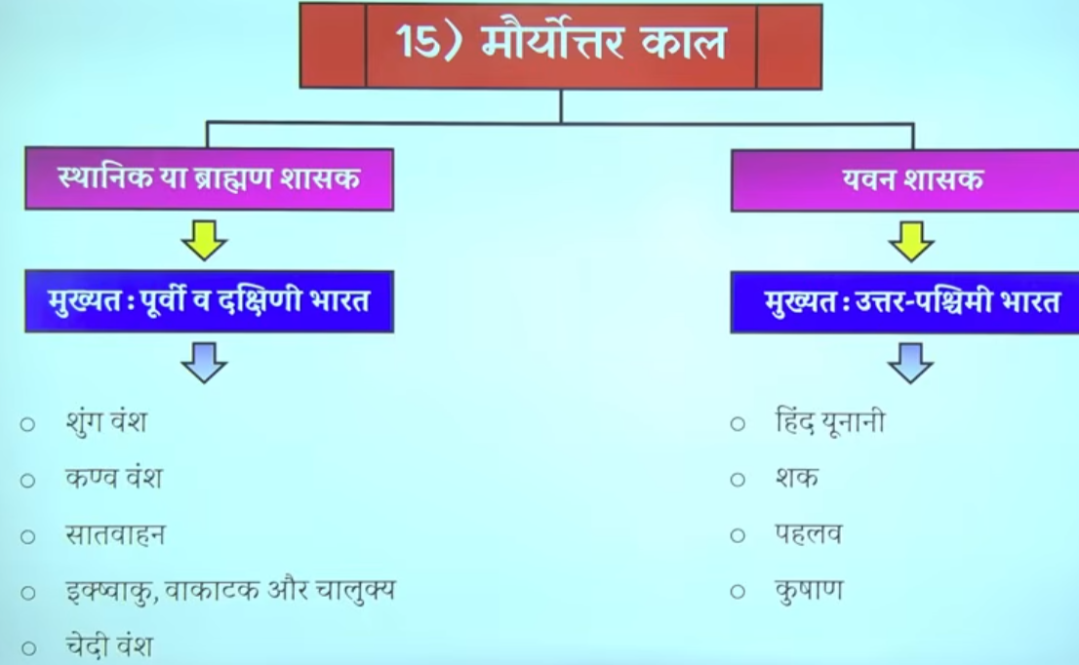

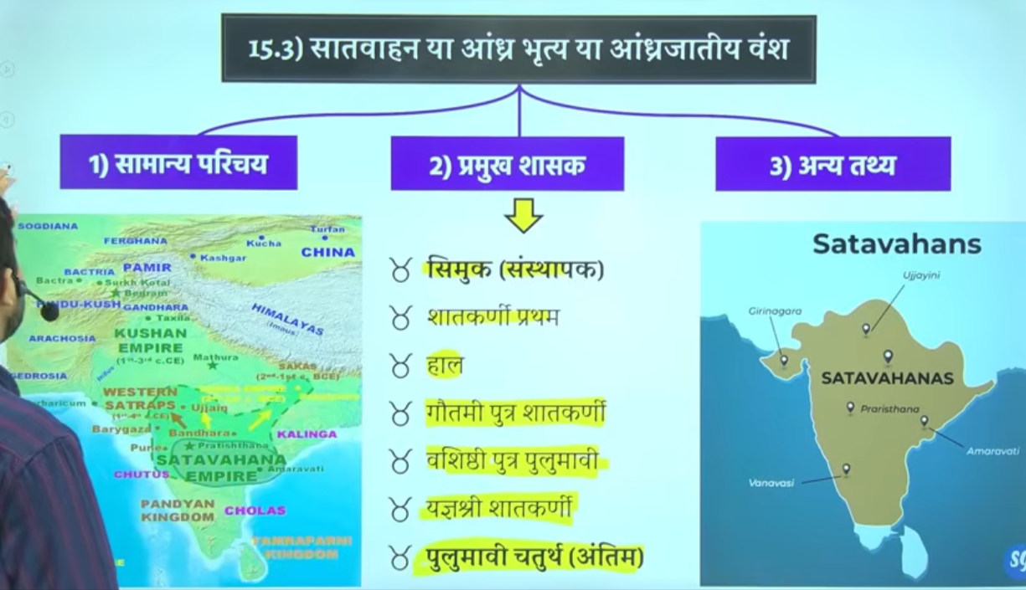

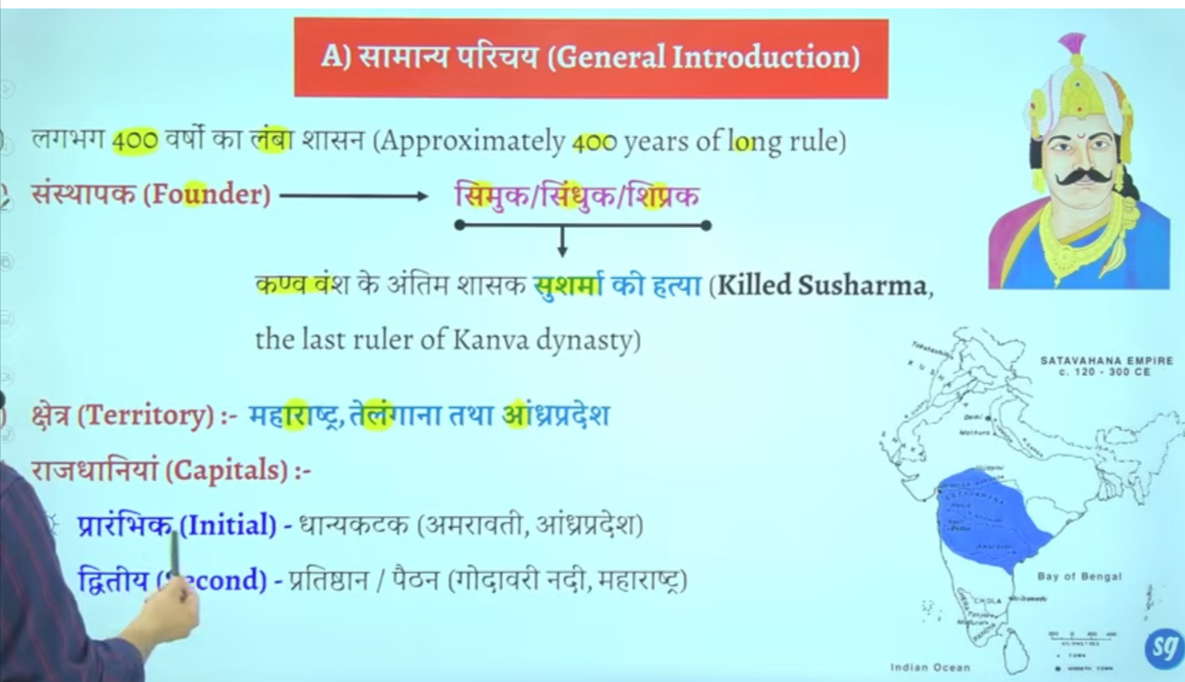

Second capital he inke main capital the prateeshan jo ken ashik wale region ke paas ate hai

Inke aupacharik bhasa official lagnauge jo the wo prakrat the aur lipi brahmi the
Isko hum vedic dharma ka punarutthan ka kaal bhe bolte hai ye pura ka pura period viedic dharma ke reconstruction ka phase hai
But inke official lagnague Sanskrit nahi the balik prakrat the sanskrat ka sabse adhik vikas hoga gutpa kaal me saknkakr ka exteme development hoga gupta period me yaha abhe bhe prakrat bharsa aur brahmil lipi ka use ho rahah tha

Sathvahan ke jankari hume Matsya pruna se milte hai
Mastsya purna me 30 kijng ka ullekh kyia gya hia
Question Matsya puran ka sambhand prachein kaal ke ksi mukhya roop se kis vansh se rahah hai to answer satvhana se rahah hai

Sathvahn ke 30 rajao ke jankir mastya pruan se mitle hai
Question mauryaon ke janskari hume kis puran se milte hai

Sathvan ne uttar aur daskshnin bharat ke beech me setu ki tarha kaam kyia they work as a bridge between north nd south india

Inke jo chinaha rahah hai usko Ujjain symbol boteh the
Ye inka official symbo hai isko lekar ke bahtu doutbh hai bahut sare book hai jo isko rectify nahi karte hai
Jo isko sahe nahi mante

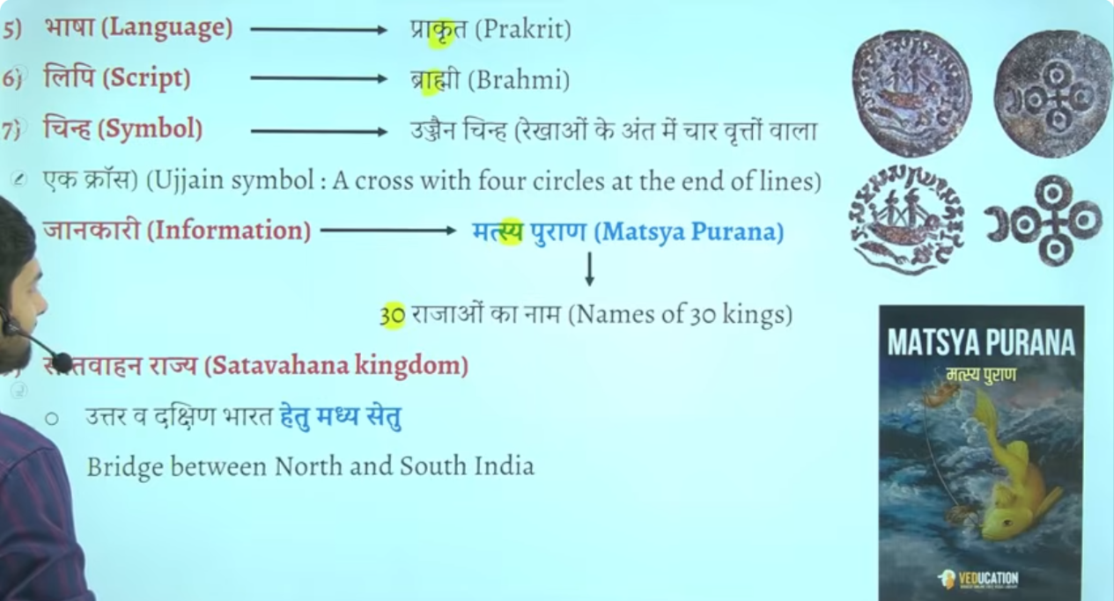

Upsc question tha ek buddha stoupa hume dhanyakata se mila hai wo dhanyakata k kahah per hai
This question is related from here
Ans:Andharparesh
Because Amravati buddhist centre ke roop me bhe develp hoga is time period me Amravati dhanykatak wala jo Chetra hai
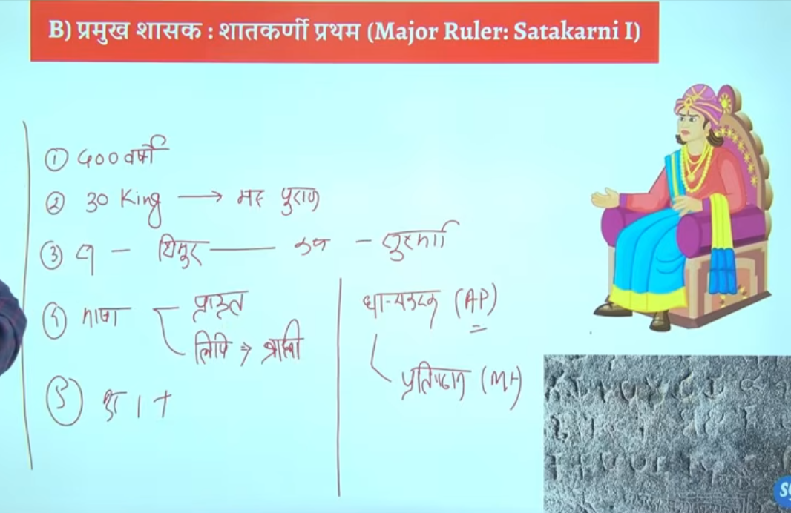

Is dynasty ka first prominent ruler ya mahan shahsak manaj jata hia
Wo hai satkarni Pratham
Saktakrini ke bare me jo hume jfankari milte hai wo inke wife nagneka ke nanaghat abhelekh insprition se milte hai jo mahrastra ke pune jile ke junnar me is the hai

Pune me ke jagah hai junnar junnar me he nanaghat abheelekh milta hai jise nayanika abhelkeh bhe kahah jata hai ya isee ko nagneeka abheelkhe bhe kahah jata hai
Ek he naam hai chae app nanaghat abheelkhe bolo ya nayanika abhelkeh bolo nagneeka abhelieha bolo

In sathvhan dynasty there are two inscription that are very very important
First is nanaghat inscription
Second is nasik inscription

Nanaghat inscritpon ko satkarni first ke wife nagneka ne lihwaya banwaya tha the nanagahat inscription is was inscribed by the wife of satkarne fiest nagnaeeka also called nayaneka
Wheras the nasik inscription inscribed by the mother of gautmi satkarni balshri gautmi or Gautami balshri

Nanaghat inscription isley important hai kuki ye bharat me bhumi anudan ka fiest sakshya hai first evidence of land grants in india to brahmins

Isse pahel kabe bhe logo ko bhumi dan nahi de jate the brahmano ko ya fir dusre logo ko kise ko bhe nahi
Genearly kya hota tha ki vihar banaw dyia ya mandi banwa dyia etc
Ab proer tareeke se land donate kyia jayega brahmano ko land grant de jayege buddishi ko land grant de jayege jains monks ko bhe land grant de jayege

To land grant ka first evidence is sathvahans se milta hai kb kbhe 1010 5050 village daan me de dyia jata tha vidhawano ko scolors ko ya brahmin s ko ya monks ko ya saints ko santo ko
Yahe se bharat me feudiliasm ke Shurat hue samantvaad ke Shurat hue the jisse age chalkar ke gutpas kae patan ka karna baen the jo bahut jyada effect kyiat tha guptas ko aur uske baad ke dynasty ya rajon ko
Man lo humen kese vyakti ko 100 gaon de dyia ab use kahah jata tha ki ab yaaha per sab kuch tumko sambhalna hai prashans bhe tum samhano halaki basic rule s rjaa ke he chalte the
Lenkin generalyy tum yaha ke sarvesarva ho tax ayega to tum collect kar lenga thoada bahut hoga to state ko de dena kuch to brahmdeya jaise jameen milte the brahmadeya aise jammen hote the jis per kise bhe prakar k koi bhe tax nahi lyia jata tha
Jisse samanto ne dhere chote chote rajya bana lyia aur jb state me kamjor shashak aye to inhe samnto ne un rajao ko alag kareke king maker ke bhumki banan shuru kar dyia tha
Yahe se bharat me samantvad ke Shurat hote the
Samantvad bhatu simple se philosophy hai ek vyakti hai jiske paas jameen ka bahtu bad tukda hai us jameen ka wahe malik hai us per use ka shashan chalta hai uar jo wahah se rajasva mil raha hai wo use se apna jeevan yapan karta hai
To prashna puchat hai ki brahmano ko bhumi anudhan ka pahla sakshay kaha se milta hai to answer is nanaghat abheliekhs se

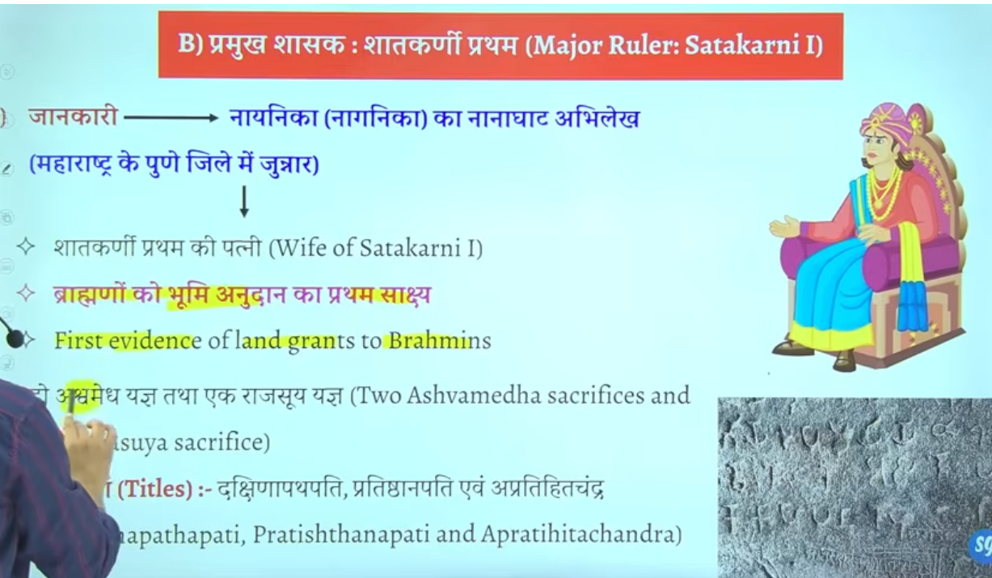]
Yaha e exam me do question bante hai
Oldest evidence of land grant in Indian is nanaghat aur sathkarni time period
Kisne banaya – to answer is pune me satkarni first ke wife nagneeka ne banywa tha ye pun eke junnar me is the hai

C HAAL
Haal ke time per apko adminstrativ wok jyada nahi milega litreatrue ya sahetya ka bhaut bada premi tha kaha jata hai ke Dakshin bharat me sahetya ke sabse bade premyiaon aur sanrakshako me haal ka naam shamil hai bahtu sare vidwaaano ko isne sankrakshan dyai tha
Isek time per bhaut saren grantho ke rachna hue the
Ye khud bhe ek bahut bada scholor tha haal ne ek famous book likhe hai gatha saptsati
Question gatha saptaste book kiske dwara likhe gae to answer satvahan raja haal ne ye book likhe the
Ye book prakrat bhasha me hai jisme prem aur shivaaa ke bare me charch ke gaee hai
Prakrat sahtvahano ke aupchariek official bhasha hai

Iske darbar me bahtu sare scholor rahet the

Prachin bharat ke sanskrti ke mahan vidwano me acharya padini ka naam ata hai patnajali aur sarvarman ka naam bhe ata hai
Sarvarman ne katantra book likhe sanskrti graamar hai one of the greatest work on Sanskrit grammar
Haal ke jo rani hai malyavati hai wo bhe Sanskrit ke bahtu bade scholor the

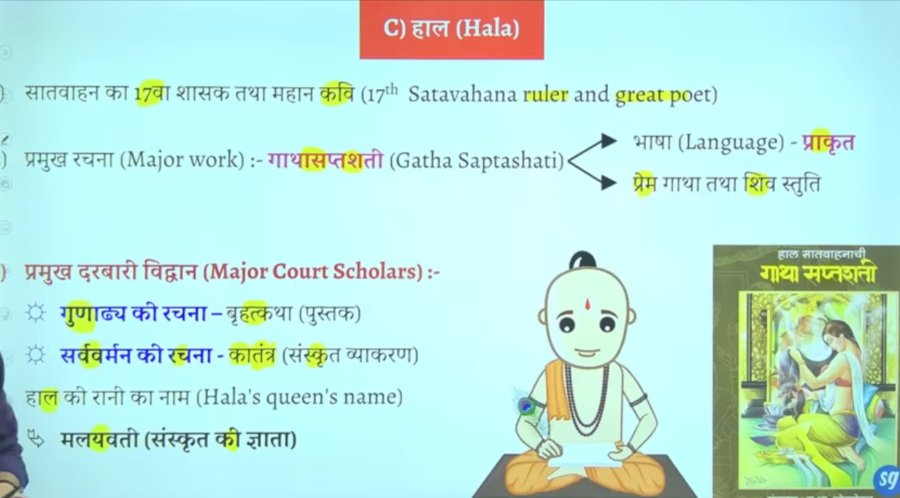
Book me prayer of shivaaa hai gatha saptshati

Greatest ruler of sathvaha is Gautami putra satkarni
He is the main ruler
Yahe seek prarmapra ke shruat hoge ke satvhan shashak apne naam ke pahel apne mata ka naam lagana shur karenge gautmi balshri inke mata ka naam tha
Ek samaya aisa ayega ke inke seemaye tamilanidu and kerla tk touch honge
Inke time per extreme expansion hoga
Inke bare me jankari hume nasik inscritpon se milte hai

Jisse inke mata gatumi balshri ne likwaya tha nasik inscritpon isse hume bahtu sare jankari milte hai regarding gautmai putra satkarni
Inhone bahtu sare title upadyia le the

Jisprakr shung ne durbar se vedic dharma ka uttahn kyai uske punaristhapan ke waise he gautpmi putra satkarni ne bhe vedic dharma ke uttan ke lyie bahut sare kaam kyie the vedic relgion ke rejunvendation ke lyie bahtu sare kaam kyie the

Kis rjaj ko varna vyavsth ka rakshak kaha gay to gautmi puta satkarni kise vedo ka ashryadata kaha gya too same answer
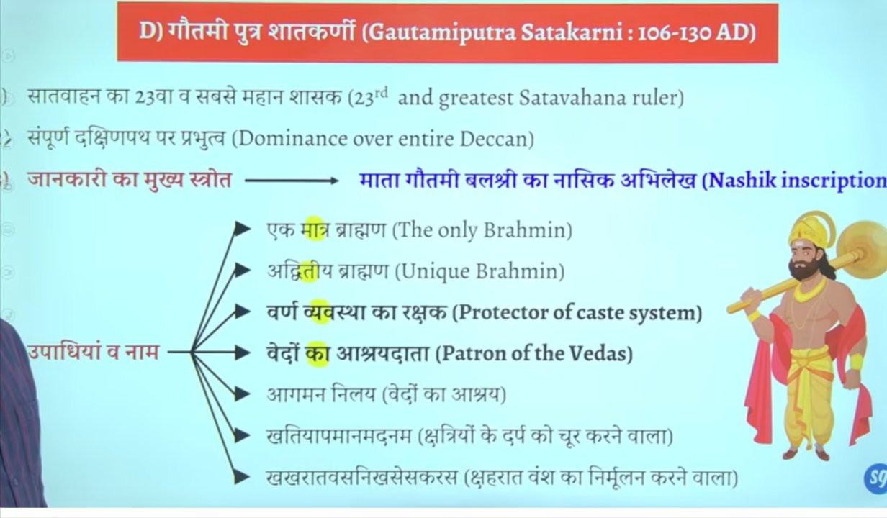

Panavlene ke caves kaaha per hai to anseer hai ye nasik mahrastra me hai
Nasik prashti ko he mahrasta me nasik gufa cave bhe bolte hai

Ye panavlene ke cave hai ineme he apko nasik inscritpon milega

West me sako ke ek shakha branch the wester shatrap rule karte the inke he ek aur shaka branch the jisko shahraat kaha jata tha iska ke rajah tha nahpaan jisko harya tha gautmi putra satkarni ne

Aisa nahi hei ke sirf brahmano ko daan dyia gaya balik buddha aur jain monk ko bhe daan dyia gaya tha land grants
Jaise narjak aur ajaakalkyia naam ke do village the jo budhha sangh council ko daan me dyia gaya tha
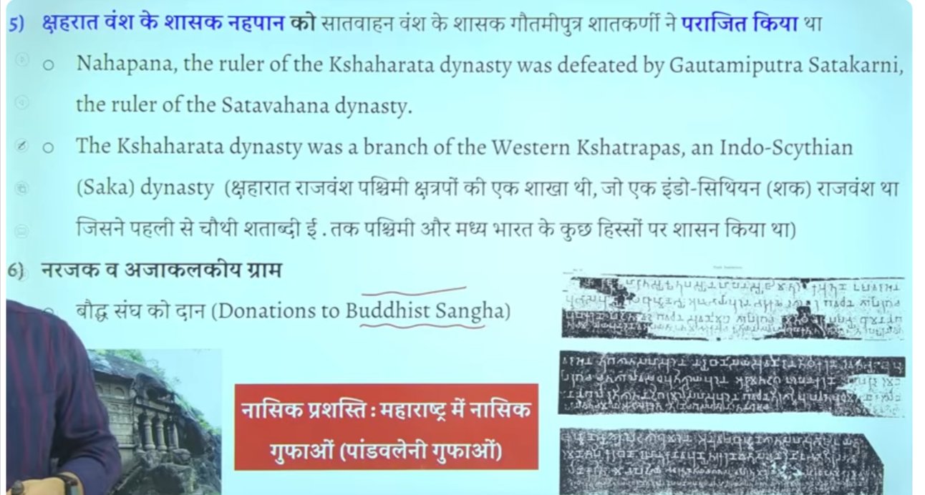

Nasik abheelke inscritpon hume pandavlenek cave nasik se pratpt hota hai jisme isko bahut sare title dyia gaye hai

Shako ke sharahat branch se nahpaan ata tha cythina ruler nahpana tha

Vashtiputra pulvamaiv
Ye bhe ke imprtonat aur mahan raja hue hai sathavna time ke

Sathvan vansh ke kaun se raja the jinhone dakshinapatheswar ke upade title lyia tha
To answer is vashisdha ptura pulvami
Ikse alaw title tha Andhra smarat and puloma

Inke jankari hume kanheri inscritpoin se milte ahi usme likha hai ke shak rjaja rudrdaman ne vashtid putra pulvami ko hara dyia tha
Shako ka mahan rja tha ruddraman jisne jungarh ka inscription bhe ankkeet karwaya tha
Firs isne pulavami ne rudradaman ke beti se shadi kar le aur dono ke beech sandhi hog ae the

Iske sikko per do patvaar wale jaha the
Jisse ye pata chatla hai ke kahe na kahe inhone navy bhe bana le the aur ship ka proyog karne lage the

Kuki satvahan roman se bahut sara trade vypar karte the kuki bahtu bade matra me roman coins india se mile hai
Q us raja ka naam bato jisek sikko per do patvar wale jahah ka chinha mila hai to answer is vashdi putr apulvami
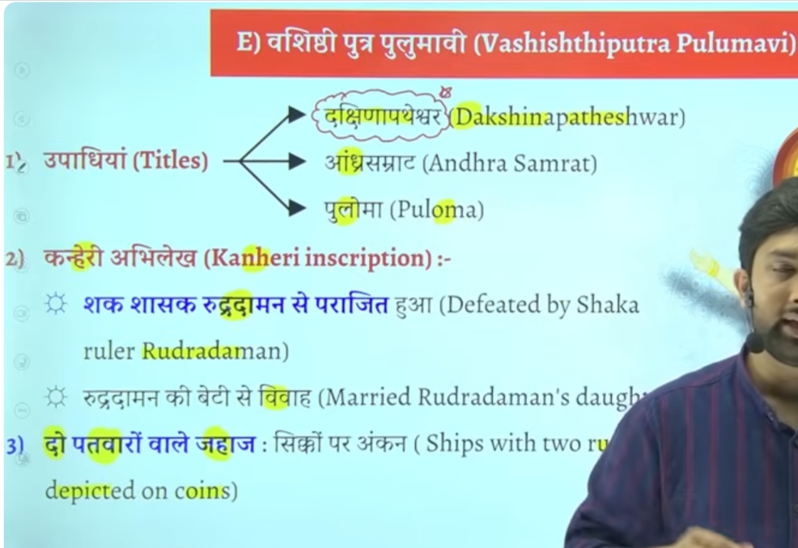

Facts

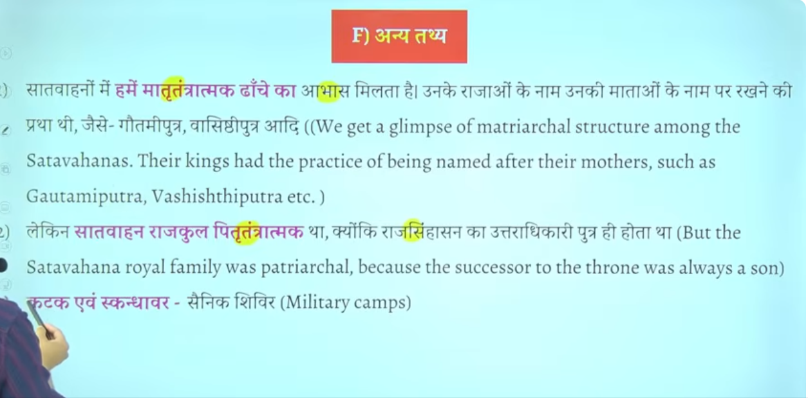

Katak aur iskandhawar ye military camps ke lyie use wone wala word tha ye saineko ke shiver ko kahah jata tha
Gaulmik = ekadhikari hota tha jo gram prashashan ka pramukh hota tha
Baki inka prashans Maurya kaal ke tarha he tha bas ek do word he importna thai
Ye ruler administration ka head hota tha ikse jimedare hote the ek ye ek sena ke tukade ko maintain karta tha military ke ek wing ko bhe maintain kart atha
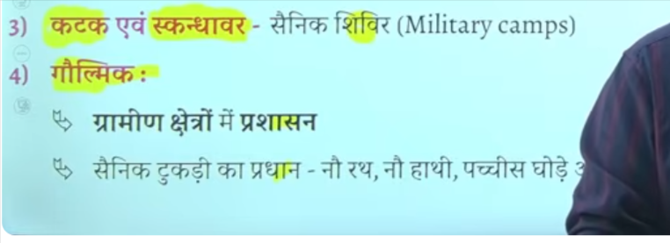

Bhut bade matra me roman sikke mile hai india se jisse ye pata chalta hai ke inke time per romans ke sath vyapar trade bahtu acha tha

Potin me seesa taba copper kansa in sab ko mila dyia jata tha

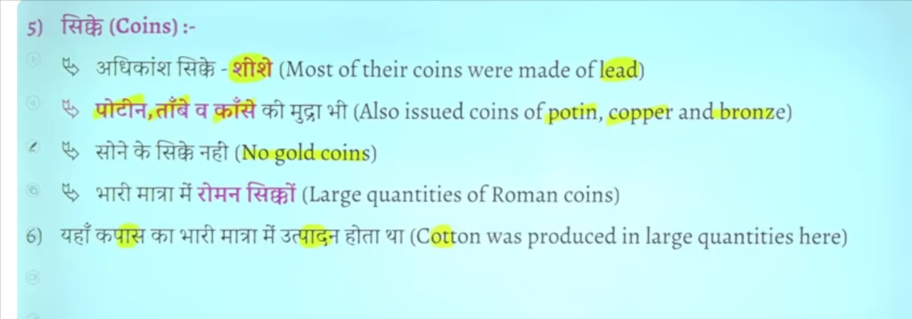

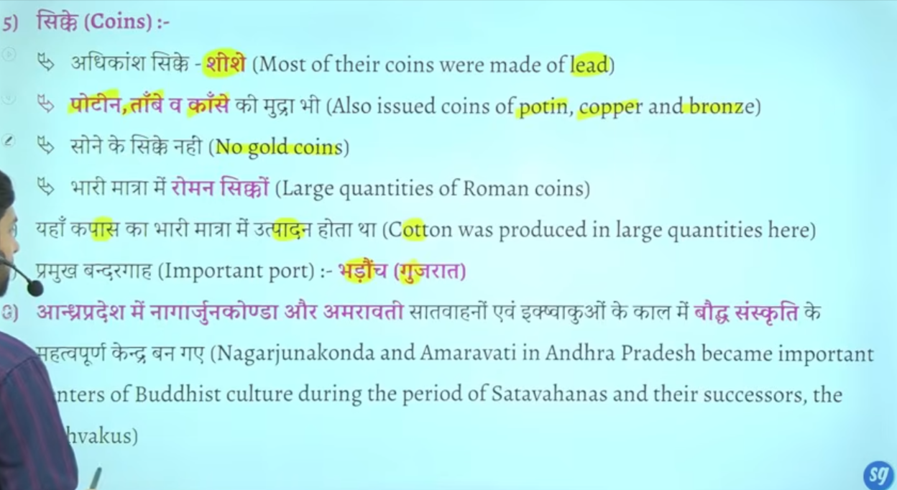

Gautmai putra satkarini vedic dharma ke sath anya dhrmo ka bhe samamn kartha tha baki dharmo ke lyei bhe karya kyai aur daan dyai aisa nahi hai ke sirf brahamano ke lyie daan hau baki dharmak ka bhe sanrkashan kyai tha
Andraprades me nagarjunkonda , dhankatak Amravati buddha sansktri ke important centraer the
Daskhin bharam me important budhsit center ban gae the
Danykatka Amravati me to stup aur chaitya bhe dekhne ko milte hai
Jaise pune maharastra me karle beds eke cave bane gae the
Jaha karle chaitya ka Nirman hua tha
Vihar wo jaahg jaha buddha monk rahte the
Chaitya wo jagha jaha per wo puja karte the

To karle chaitya aur bedse cave kaha ishte hai to anser is pune mahrasta me

Sath he satvahan shasko ne ajanta aur elaalor me bhe kuch gufao ka Nirman karwaya hai

Ajanta aur ellor ke gufaye aise hai jisme satvahan rastrkoot vaktaka bahut sare king ne kaam karwaya tha
Multiple rulers ka contribution rahah hai to sathvahana ka bhe yogdaan rhah hai jo mahrasta me pae jate hai

